Abstract— Image blur is persistent in most images taken when a camera is hand-held. The blur may vary from being an acceptable bokeh to values that can ruin the photograph. This project simulates two image deblurring techniques that have been previously accomplished successfully and performs a comprehensive comparison of the result. In this project both subjective and objective methods have been employed to evaluate the deblurred images. The first method[1] involves using two images, viz. a blurred image and a low exposure image captured by the camera at high shutter speeds. Whereas, the second method[2] performs deblurring by a blind de-convolution of the blurred image with a point spread function generated using sensory data. In the end a third method is proposed that attempts to perform a fast and computationally economical solution.
Project Report: Digital Image Processing EESC6360
Parth Parikh (UTD ID: 2021165745)
Department of Electrical Engineering, The University of Texas at Dallas
pxp126130@utdallas.edu
Keywords: Image Deblurring, Hand-shake, Low Exposure, Point Spread function, Histogram matching.

INTRODUCTION
Computational photography refers to computational image capture, processing, and manipulation techniques that enhance or extend the capabilities of digital photography. It encompasses operations like panoramic addition of images, HDR photography, deblurring among others. Image deblurring is one of the fundamental operations that a consumer would want in latest cameras and smart phones. Although present devices have hardware facilities for vibration resistance, the blur caused by “hand shake” is often very difficult to remove and needs post processing. Various image debluring methods have been proposed to date. This project studies the effective ness of two of them.
The primary advantage of performing on-device image deblurring is that, one does not have to wait for the exact moment to click a picture. Most people handling cameras are novices and are not professionally trained to exploit the features of present day devices to their fullest advantage. Hence a feature of auto-deblur will be a boon for amateur photographers and camera users in general.
Some of the researches done recently in the image deblurring sector include:
- Colour Bake Inspection System Using Hybrid Artificial Neural Networks.[4]
- Fuzzy Methods for Automated Inspection of Food Products.[5]
- Fuzzy Models to Predict Consumer Ratings for Biscuits Based on Digital Image Features.[6]
- Invariant Recognition of Rectangular Biscuits with Fuzzy Moment Descriptors, Flawed Pieces Detection.[7]
- Texture Analysis for Biscuit Using Wavelet.[8]
Considering the biscuit industry in specific, the various cookies and biscuits form an integral part of breakfast and snacks in most of the countries. Therefore, manufacturers in order to sustain in the tough competition, have to ensure superior quality in terms of physical appearance along with the hygiene and taste. India is one of the major producers and exporters of various forms of cookies. USA, Canada, Eastern and Central Africa and other major countries offer a huge market to the Indian biscuit industry.
In this paper we propose four quality parameters to measure the quality of chocolate cookies and propose an algorithm to measure the quality of cookies. In section 2 of this paper we discuss the problem definition and its relevance in detail. Section 3 is a discussion of the tools used. The proposed algorithm for quality evaluation along with the proposed quality parameters is discussed in section 4. Section 5 contains the observations of applying the various tools and their analysis. Finally section 6 concludes the paper followed by references.

PROBLEM DEIFINITION
To evaluate the quality of a chocolate chip cookie based on the number of chocolate chips, their size relative to the cookie itself, the chip area and their distribution relative to the cookie as a whole.
Quality control is essential in the food industry and efficient quality assurance is becoming increasingly important. Consumers expect the best quality at competitive, affordable price along with a good shelf-life and taste satisfaction. In food industry most of the products are evaluated on the basis of human perception which can produce erroneous results.
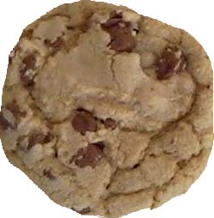  (a) | 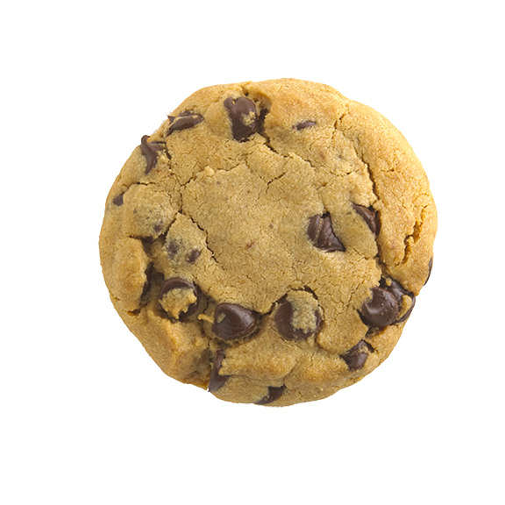  (b) | 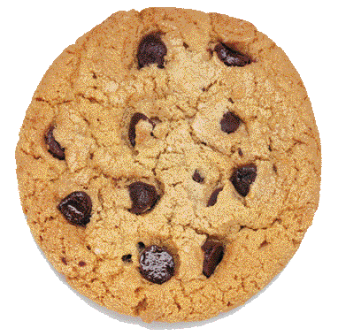  (c) | 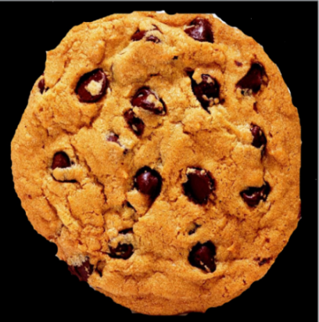  (d)
Fig. 1: Images of various sample chocolate chip cookies.

The aspects of the cookies shown above from the quality and evaluation point of view are described in Table I below.

TABLE I: QUALITY AND EVALUATION ASPECTS OF COOKIES GIVEN IN FIG. 1.
IMAGE | QUALITY ASPECT | EVALUATION ASPECT
A | It has too many cracks and less no of chocolate chips. | It is a low contrast image and thresholding will be difficult.
B | It has a few big cracks and all chocolate chips are concentrated in a small area instead of uniform distribution. | While region growing all the nearby chips will merge into a single large chip giving erroneous results.
C | A few chocolate chips in the cookie in figure C are too small and a few too large. | The size of these small chips is comparable to some of the bigger cracks, so separating the two after thresholding and region growing will be difficult.
D | The cookie in figure D satisfies all quality parameters defined in section 4. | It has all the problems mentioned above except contrast problems. It has another problem of separating the cookie from background. This problem is severe in case of uncertain background.

Here the role of a non-manipulative, robust system becomes necessary, which can be easily achieved using machine vision. The sample images are so chosen that each of them have a peculiar problem of quality as well as a problem that will arise during computation. Images of various cookies considered for evaluation are given in figure 1 (a)-(d).

Tools used for evaluation

Automatic Thresholding
Here instead of a fix threshold value, which may create problem when the colour of the cookie or more possibly the illumination of the ambience changes, we propose to use an appropriate value of threshold to separate chips from biscuit is calculated from the image itself. The histogram method is a very crude method for automatic thresholding. Yet this method is very effective in case the image is mainly concentrated in two or three major sections as shown in figure 2. Its simplicity and effectiveness is what lured us to use it in this case. The histogram of the cookie will be concentrated in two major regions, one around the colour of the cookie and the other around the colour of the chips.
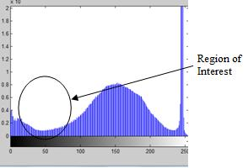
Fig. 2: Histogram and region of interest

Appropriate threshold will lie somewhere in between the two regions. The exact location of this threshold value can be estimated from the shape of the histogram. The value for the threshold is obtained as the global minima of the histogram. This value can be extracted using inbuilt functions of MATLAB. Another sophisticated manner of dealing with this problem is Otsu’s Automatic Thresholding [9].

Segmentation and Region Growing Techniques
Region growing [10] examines neighbouring pixels of initial ‘seed points’ and determines whether the pixel neighbours should be added to the region. The process is iterated on, in the same manner as general ‘data clustering’ algorithms. The main goal of segmentation is to partition an image into accurate regions, especially at the boundary of segments. Some segmentation methods such as ‘thresholding’ achieve this goal by looking for the boundaries between regions based on discontinuities in ‘grey levels’ or colour properties. The segments tend to deform at the boundary when thresholding is applied and this is overcome by region growing. ‘Region-based segmentation’ [11] is a technique for determining the region directly.
The iterative region growing and segmentation technique to convert the chips in to a moderately round shape while suppressing the cracks is used. Cracks, which usually tend to have a peculiar shape with large length and negligible width, can be identified from the eccentricity of segments or from difference in the major and minor axis length of the segments. Also smaller chips tend to be seen in two or three different parts in the image. They are combined into single chip hence avoiding erroneous results.

Morphological Operations [12]
Mathematical morphology is a technique for the analysis and processing of geometrical structures, based on ‘set theory’, topology and random functions.
Like graphs, surface meshes, solids, and many other spatial structures, it is also commonly applied to digital images. We have used two chief morphological operators.
1) Close Operator: The closing of A by B is obtained by the dilation of A by B, followed by erosion of the resulting structure by B.
2) Open Operator: The opening of A by B is obtained by the erosion of A by B, followed by dilation of the resulting image by B.
Close operator is used for separating out the cookie from its background. And the open operator is used for filling out the holes in the image of the chocolate chips.

Canny Edge Detection [13]
Canny edge detection technique based on directional gradient, non-maximal suppression and hysteresis thresholding, is one of the best technique in terms of suppressing false edges and enhancing the actual ones.
Canny edge detection is used to separate out the cookie from the background. It is a must step to calculate the area of the cookie. The threshold value for canny edge detection should be the lowest possible, but care should be taken so as not to detect the slight shade variation outside the cookie which is common in case of lossy jpeg compression. In this evaluation a threshold value of .001 is used.

Quality Parameters and Proposed Algorithm

Quality Parameters
In this subsection we define various parameters, variables, constants and tolerances that are used to evaluate the quality of the cookies. The quality is evaluated on the basis of four quality assessment parameters namely: Quality parameter for number of chocolate chips (P), area efficiency (E), single chip area (S), uniform distribution parameter (G). They are defined by the following equations:

P = (| (N - N_{o}) / N_{o}|) * 100 … (1)
E = (| (n - n_{o}) / n_{o} | ) * 100 … (2)
S = (| (S_{a} - S_{o}) / S_{o} | ) * 100 … (3)
G = (| (D - D_{o}) / D_{o}|) * 100 … (4)
Where,
- N_{o} = Optimum number of chocolate chips.
- S_{o} = Optimum area of single chocolate chip.
- n_{o} = Optimum area efficiency.
- D_{o} = Optimum distance.
- N = Number of chocolate chips.
- S_{a} (area of single chip) = Ac/N.
  - A_{c} = Area of chocolate chips.
- n (area efficiency) = Ac /Ao.
  - A_{o} = Area of cookie.
- D (C,C_{o}) = Euclidean Distance between C and Co.
  - C (X,Y) = co-ordinates of centre of image.
  - C_{o} (X_{o},Y_{o}) = co-ordinates of centroid of image.
The various tolerances included in the evaluation are as given below:
- t₁ = Allowed percentage tolerance in No.
- t₂ ₌ Allowed percentage tolerance in n_{o.}
- t₃ = Allowed percentage tolerance in So.
- t₄ =Allowed percentage tolerance in Do.

Algorithm for Quality Evaluation of the Cookie

TABLE II: PROPOSED ALGORITHM
No | Step
1 | Acquire image of a cookie under inspection, call it I.
2 | Apply grey-scaling algorithm on I, call it I₁.
3 | Apply canny edge detection algorithm on I₁, call it I₂.
4 | Apply morphological close operation on I₂, call it I₃.
5 | Calculate the area, A_{o} of the cookie from I₃.
6 | Apply automatic thresholding on I₁ to convert to binary image I₄.
7 | Separate cracks from chips using algorithm given in Table III.
8 | Count number of chips, N, chip area, A_{c} and D.
9 | Allot grades to individual parameters, viz. P, E, S and G using logic of Table IV.
10 | Allot overall grade to quality parameter Q.
The steps of the algorithm illustrated in Table II are explained in detail as follows:
The image of the cookie is acquired. The next step is to grey-scale the colour image. The third step is to perform edge detection using canny edge detection algorithm. Then we apply morphological close operation which yields an image that separates the cookie from its background. This is used to count the area of the entire cookie (number of pixels) in the fifth step. Then we apply automatic thresholding discussed in section 3.1 to the grey-scaled image. It is expected that the histogram be concentrated in two major regions. One is that of the chocolate chips and the other is that of the cookie itself. Depending on their separation an appropriate threshold value should be selected. The algorithm to separate cracks from the chips is discussed in Table III. The eighth step involves using inbuilt MATLAB functions that return the number of closed areas (number of chips), total closed area (chip area) and the Euclidean distance, D. The ninth step for grade allotment for a sample quality parameter, Z and tolerance level t is shown in Table IV.

Table III. ALGORITHM TO SEPARATE CRACKS FROM CHIPS.
No | Operation and/or inference
1 | Apply morphological closing operation with disc template on binary image I₄ to get image I₅..
2 | Remove all the segments with area less than 5% of that of the cookie I_{5,} call this image I₆.
3 | Remove larger cracks that remain in I₆ by limiting the length-width ratio of the segments in image yielding image I₇.

Table IV. LOGIC FOR EVALUATION OF INDIVIDUAL PARAMETERS.
Step | Description
1 | Read value of Z, t.
2 | If Z lies in the range [0,t] , Grade A.
3 | If Z lies in the range (τ,2t]and Z≠100, Grade B.
4 | If Z lies in the range (2τ,3t] and Z≠100, Grade C.
5 | If Z lies in the range (3t,∞], Grade D.

Tenth step of allotment of overall quality of the cookie is calculated as per the formula shown in equation (5):

Q = 3P + 2(E + S) + G … (5)
8

Where, the parameters are replaced by the corresponding grade (and then the equivalent decimal).
The overall quality is determined as the mean of a weighted sum of all the individual parameters. From a consumer point of view the most important parameter is the number of chips (giving P a weight of 3), followed by moderate significance to both area efficiency (E) and single chip area(S) (giving them a weight of 2 each). The least important of all is the uniform distribution parameter (giving G a weight of 1).
To calculate the value of Q from individual parametric grades, they are replaced by equivalent decimals and then reverse mapping from decimal value to grade for Q itself. The following subsections discuss the same.

1) Mapping from individual parameter grade to
equivalent decimal number:

TABLE V: GRAGE TO DECIMAL NUMBER MAPPING.
Grade | Equivalent number
A | 10
B | 7
C | 5
D | 3

Table V tabulates the decimal values allotted to the various grades for individual parameters, viz. P, E, S and G.

2) Mapping from decimal value range to grade for Q:

TABLE VI: DECIMAL VALUE TO GRADE MAPPING.
Value | Equivalent Grade
[8.25,10] | A
[6.75,8.25) | B
[4.5,6.75) | C
[0,4.5) | D
Table VI tabulates the gr ades allotted to the overall quality parameter, Q depending on the decimal value calculated from equation (5).

- RESULTS AND ANALYSIS
The result of applying the algorithm on the specimen cookie is shown in Fig. 3. The original specimen image is shown in Fig. 3(a). The grey-scaled image for the same is shown in Fig. 3(b). On applying Canny edge detection on Fig. 3(b) with a threshold value, 0.5 (or 50%) is shown in Fig. 3(c). Application of morphological close operation using a disc template on Fig. 3(c) results in Fig. 3(d). Automatic thresholding of Fig. 3(b) with a threshold value of grey value, 45, yields Fig. 3(e). The next step is applying morphological close operation on Fig. 3(e) using a disc template of radius 5. This results in Fig. 3(f). As evident the lighter cracks and smaller chips become evident. The segments of Fig. 3(f) with areas that are lesser than 5% of that of the cookie are removed resulting in Fig. 3(g). This removes the misleading cracks that might be misinterpreted as chips. The final image of Fig. 3(h) shows the result of limiting the length-width ratio to remove the larger cracks that prevail in Fig. 3(g).
The values for the parameters and overall grade for the same are given as follows:

P: A Grade ≡ 10.
E: A Grade ≡ 10.
S: B Grade ≡ 7.
G: C Grade ≡ 7.

Q = ((3*10) + 2(10+7) + 7) /8 = 8.875.
Equivalent Grade: A.

- CONCLUSION
We proposed a simple and novel algorithm to evaluate quality of chocolate chip cookies using non-destructive techniques using machine vision. The proposed algorithm works on four different types of chocolate chip cookies. The simplicity of the algorithm is suitable for online inspection in bakery industry also. Future work can be a 3D definition of quality of chocolate chip cookies using machine vision techniques.
REFERENCES
- Narendra V G, Hareesh K S, “Quality Inspection and Grading of Agricultural and Food Products by Computer Vision- A Review.” in International Journal of Computer Applications (0975 – 8887) Volume 2, May 2010.
- Kavindra R Jain, Chintan K Modi, Jalpa J Patel, “Non-Destructive Quality Evaluation In Spice Industry With Specific Reference To Cuminum Cyminum L (Cumin) Seeds.” in Innovative Technologies in Intelligent Systems and Industrial Applications, 2009, July 2009.
- Khaled TAOUIL, Zied CHTOUROU, Lotfi KAMOUN, “Machine Vision Based Quality Monitoring in Olive Oil Conditioning.” IPTA, Nov 2008.
- Jeffrey C.H. Yeh, Leonard G.C. Hameyi, Tas WestcottS, Samuel K.Y. Sung, “Colour Bake Inspection System Using Hybrid Artificial Neural Networks.” in Proceedings, IEEE International Conference Neural Networks, 1995, Nov/Dec 1995.
- Valerie Davidson, Terrence Chu, Joanne Ryks, “Fuzzy Methods for Automated Inspection of Food Products.” in NAFIPS, July 1999.
- Valerie Davidson, Terrence Chu, Joanne Ryks, “Fuzzy Models to Predict Consumer Ratings for Biscuits Based on Digital Image Features.” in IEEE Transactions on Fuzzy Systems, Vol. 9, No. 1, February 2001.
- Pulivarthi Srinivasa Rao, Sheli Sinha Chaudhuri, Romesh Laishram, “Invariant Recognition of Rectangular Biscuits with Fuzzy Moment Descriptors, Flawed Pieces Detection.” in International Journal of Image Processing, Volume (4): Issue (3), August 2010.
- Nur Shuhada Eilani bt. Ahmad, Riza Sulaiman, “Texture Analysis for Biscuit Using Wavelet.” in International Conference on Electrical Engineering and Informatics, August 2009.
- Otsu N, “A Threshold Selection Method from Grey-Level Histograms.” in IEEE Transactions on Systems, Man, and Cybernetics, Vol. SMC-9, No. 1. January 1979.
- Yian-Leng Chang, Xiaobo Li, “Adaptive Image Region-Growing.” in IEEE Transactions on Image Processing, Vol. 3, No. 6, November 1994.
- Jun Tang, “A Colour Image Segmentation algorithm based on Region Growing.” in 2nd International Conference on Computer Engineering and Technology, April 2010.
- Su Chen, Robert M. Haralick, “Recursive Erosion, Dilation, Opening, and Closing Transforms.” in IEEE Transactions on Image Processing, Vol. 4, No. 3, March 1995.
- John Canny, “A Computational Approach to Edge Detection.” in IEEE Transactions on Pattern Analysis and Machine Intelligence, Vol. 8, No. 6, November 1986.

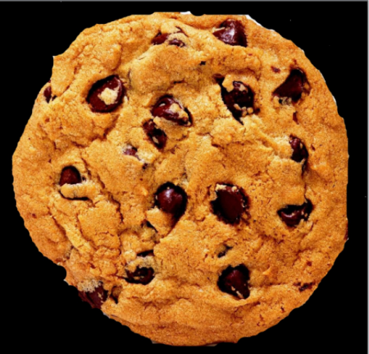  (a) | 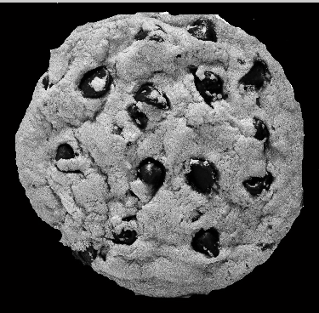  (b) | 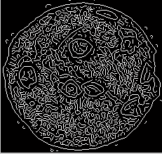  (c) | 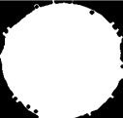  (d)
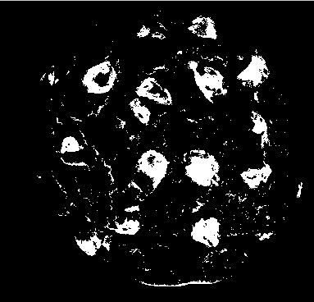  (e) | 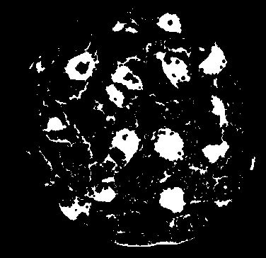  (f) | 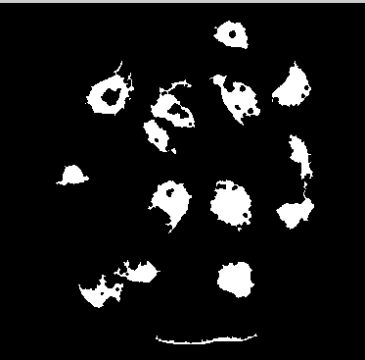  (g) | 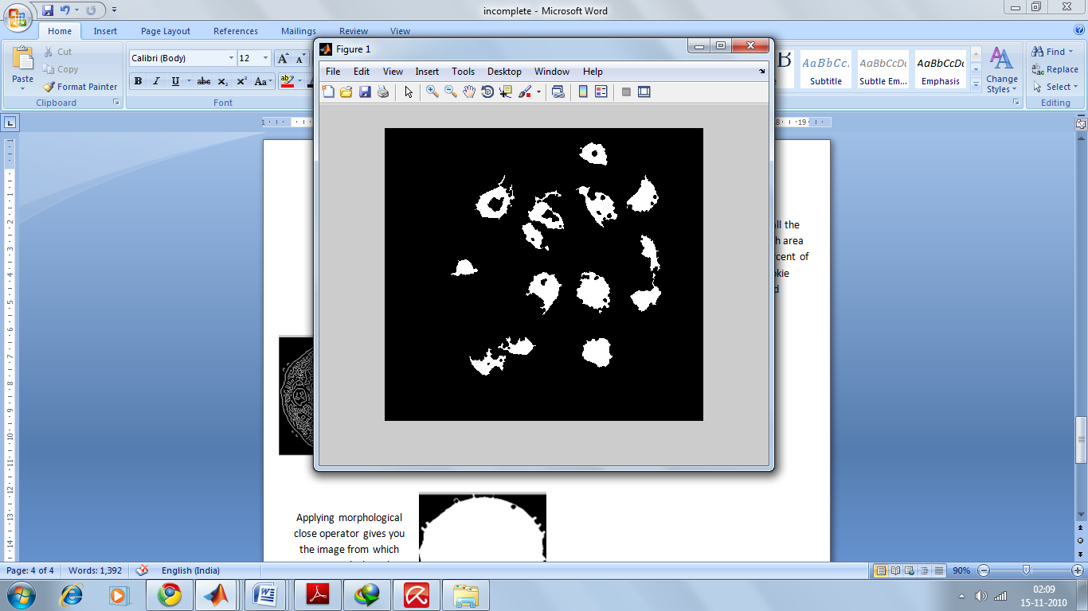  (h)
Fig. 3: Specimen image and output images after applying the algorithm on the specimen image.

 

